# WEB APP USE CASES AND SEQUENCE DIAGRAMS

The Document gives a brief description of the basic functionality that the Market Sales web application will offer and provides Use Case Scenarios and Sequence Diagrams which describes the events that will occur during interactions between a user and the Web Application.

## LOGIN

This Use case gives a sequence of events that will occur for a user to login into the system.

|  |  |
| --- | --- |
| **Name of use case** | **Login** |
| Actor/s | System Admin and Market administrator |
| Pre-conditions | User is created in the system |
| Post conditions | User logged in |
| Purpose | To enable system users to access to the system |
| **Main Scenario** | |
| **Actor Input** | **System response** |
| 1. The user loads the web app in the browser | 2. The system displays the login form |
| 3. The user fills in the login form with email and password | 4. The System validates email and password |
| 5. The actor clicks login button | 5.1. System checks email and password |
|  | 5.2. System takes user to home page |
| **Alternative scenario** |  |
| 6. User enters invalid email and/or password | 6.1. System displays invalid email or password message |

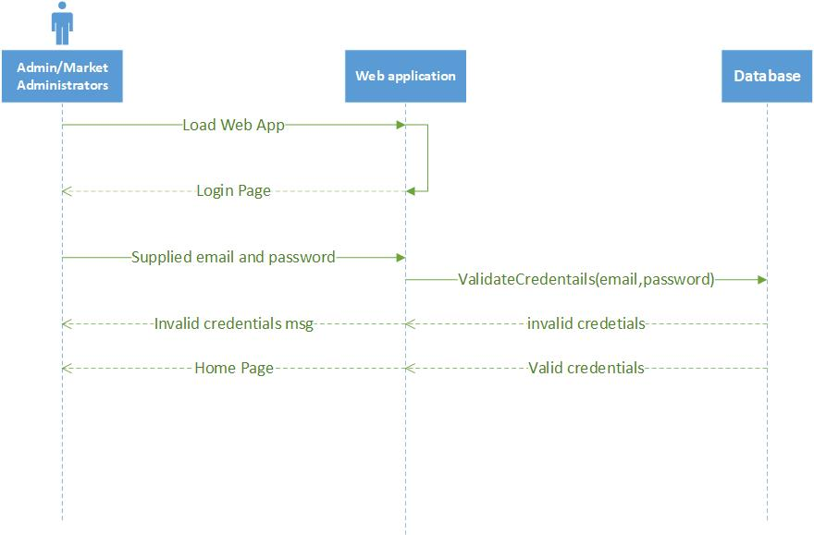

## RESET PASSWORD

This use case gives the sequence of events that will occur for the user to be able to reset their password in the case they forget their password.

|  |  |
| --- | --- |
| **Name of use case** | **Reset password** |
| Actor/s | System Admin and Market administrator |
| Pre-conditions | User forgot password |
| Post conditions | Password reset |
| Purpose | To enable user to be able to reset their account password |
| **Main Scenario** | |
| **Actor Input** | **System response** |
| 1. From the login page, user clicks on reset password link | 2. The system displays enter email form |
| 3. The actor enters email | 4. The System validates the email address |
| 5. The actor clicks reset button | 5.1. The system sends reset password link to user email |
| 6. The user opens password reset link | 6.1. System display reset password form |
| 7. User enters new password and confirm password | 7.1. System validates two passwords |
| 8. The actor clicks reset button. | 8.1. System validates email and generates password hash |
|  | 8.2. System takes user to login page |
| **Alternative Scenario** |  |
| 1. User supplies invalid email | * System displays user with email does not exist |
| 1. User enters different new password and confirm password | * System displays the two passwords do not match message |

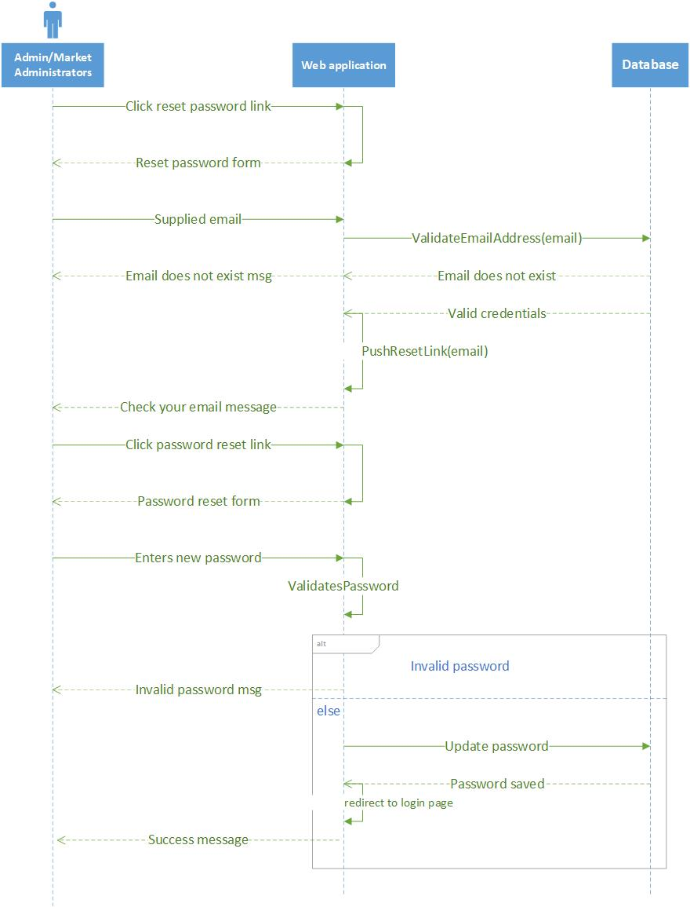

## CREATE USER CATEGORY

This use case a sequence of events that will occur when a System Administrator is creating a new User category

|  |  |
| --- | --- |
| **Name of use case** | **Create User role** |
| Actor/s | System Admin |
| Pre-conditions | Actor must be logged in. |
| Post conditions | User role created |
| Purpose | To enable System Administrator to create a user group. |
| **Main Scenario** | |
| **Actor Input** | **System response** |
| 1. The actor navigates to Roles under user management. | 2. System displays available user roles |
| 3. User clicks add new role button | 4. The system displays add role form |
| 5. User enters role name and selects role permissions and clicks submit button | 5.1. System saves role and displays success message |
| **Alternative Scenario** | - |
|  |  |

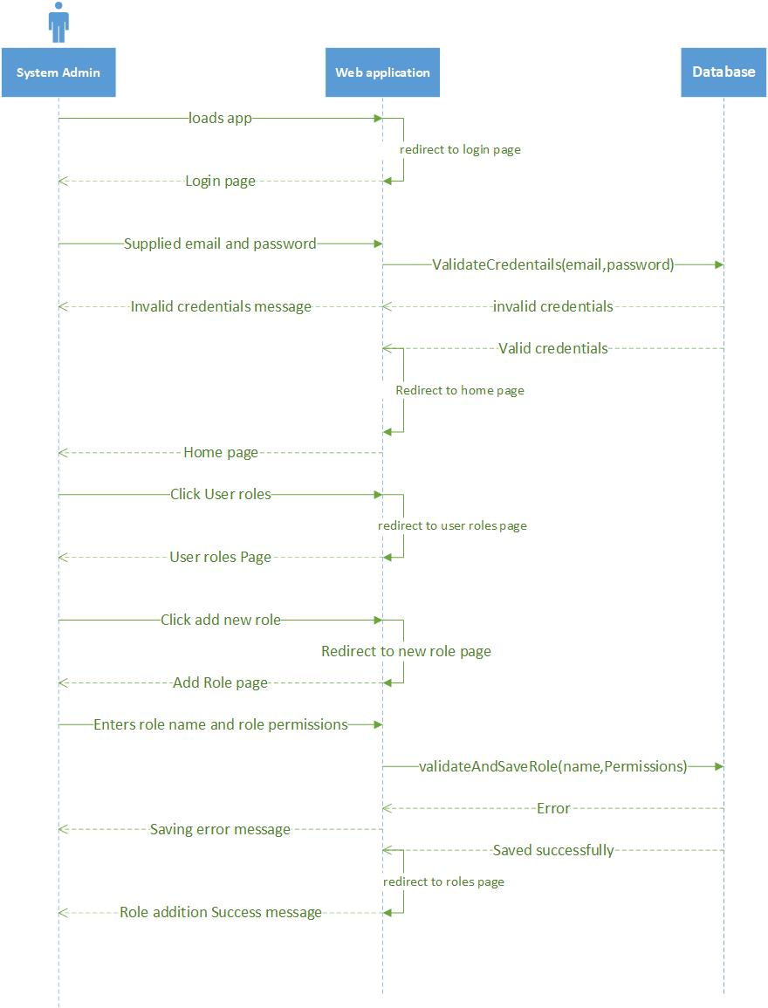

## CREATE USER

This use case describes a sequence of events that will occur when a System Administrator is creating a new web app system user

|  |  |
| --- | --- |
| **Name of use case** | **Create User** |
| Actor/s | System Admin |
| Pre-conditions | Actor must be logged in. |
| Post conditions | User created |
| Purpose | To enable system admin to create web application users |
| **Main Scenario** | |
| **Actor Input** | **System response** |
| 1. User navigates to the Users page under user management | 2. System displays available users |
| 3. User clicks add user button | 4. The system displays the add user modal |
| 5. The user fills in all details | 5.1. The system validates filled in details |
| 6. User clicks submit button | 5.2. The system checks if email does not exists |
|  | 5.3 The system saves user record and sends activate account email |
| **Alternative Scenario** |  |
| 7. User enters existing email | - System display account already exists |
|  |  |

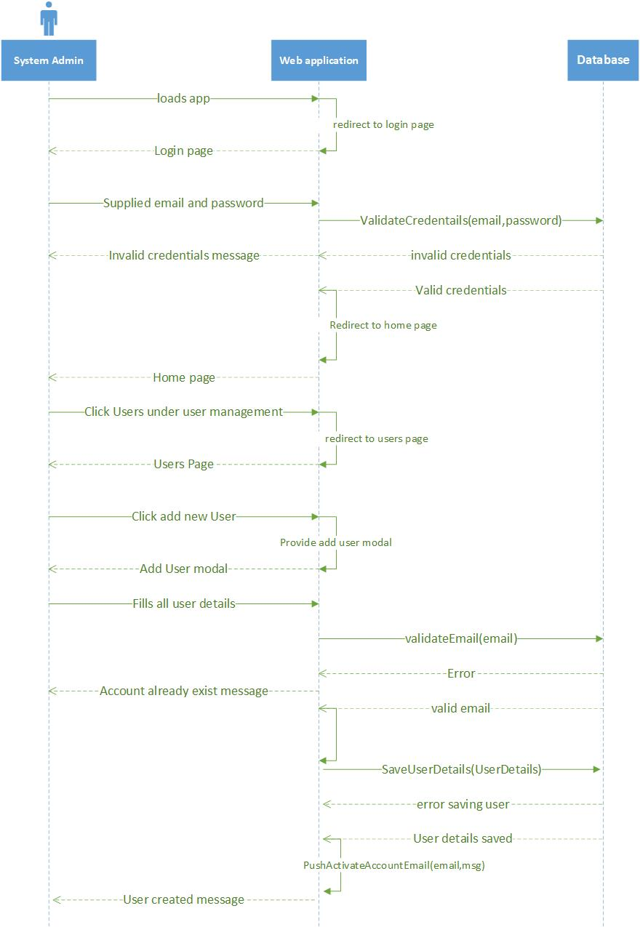

## CHANGE PASSWORD

The use case describes a sequence of events that will occur when a System user wants to change their system account password

|  |  |
| --- | --- |
| **Name of use case** | **Change password** |
| Actor/s | System Admin and Market administrator |
| Pre-conditions | User is logged in |
| Post conditions | Password changed |
| Purpose | To enable user to be able to change their account password |
| **Main Scenario** | |
| **Actor Input** | **System response** |
| 1. User selects change password from the drop down menu | 2. The system displays change password form |
| 3. The use enters new password and confirm password | 3.1. System validates passwords |
| 4. The actor clicks change button. | 4.1. System generates password hash |
|  | 4.2. System takes user to login page and displays success message |
| **Alternative Scenario** |  |
| 1. User enters different new password and confirm password | * System displays the two passwords do not match message |

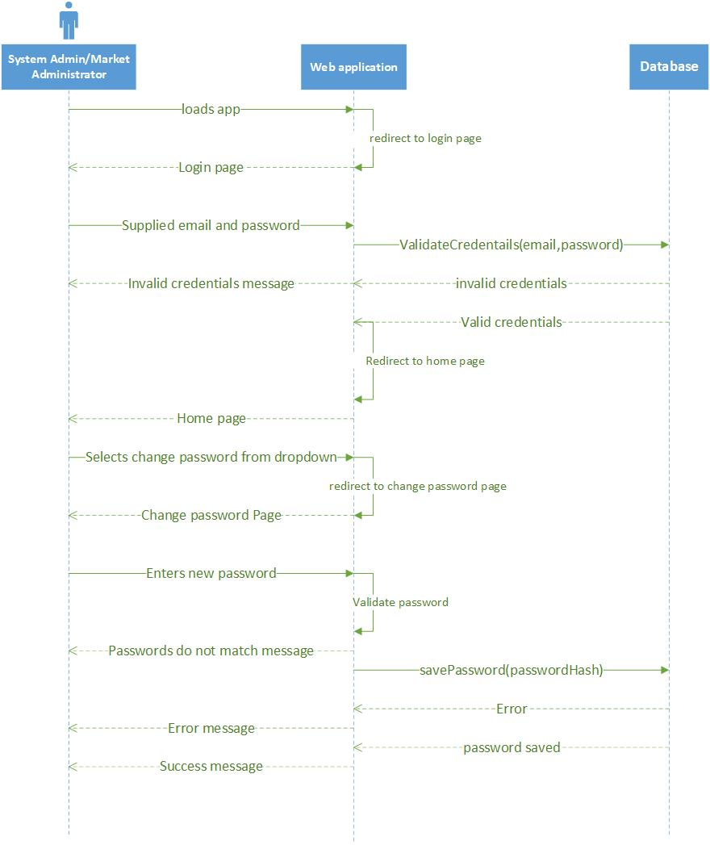

## EDIT PROFILE

The use case describes a sequence of events that will occur when a System User wants to update their personal details

|  |  |
| --- | --- |
| **Name of use case** | **Edit Profile** |
| Actor/s | System Admin and Market Administrators |
| Pre-conditions | User must be logged in. |
| Post conditions | User profile successfully Edited |
| Purpose | To enable System Admins and other users to edit their system account details |
| **Main Scenario** | |
| **Actor Input** | **System response** |
| 1. The user selects My Profile from the drop down list | 2. The system displays User profile form |
| 3. The actor fills in the form. | 4. The system validates the inputs. |
| 5. The actor selects submit. | 5.1. The system saves the edited details |
|  | 5.2. The system displays profile edited successfully message |
| **Alternative Scenario** |  |
| 1. User enters an invalid input | * System displays invalid input message |

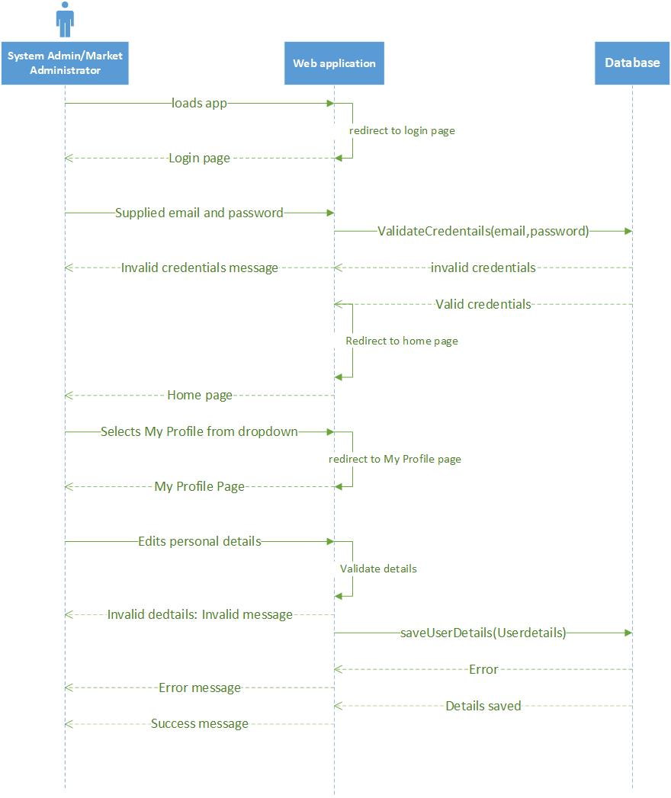

## BLOCK TRADER

The use case describes a sequence of events that will occur when a System Admin or Market Administrator wants to block a Trader from using the Market Sales System and the Market facilities.

|  |  |
| --- | --- |
| **Name of use case** | **Block Trader** |
| Actor/s | System Admin and Market Administrators |
| Pre-conditions | User must be logged in. |
| Post conditions | User Trader Account successfully Blocked |
| Purpose | To enable System Admins and Market Administrators to Block Marketeers and Other Traders account. |
| **Main Scenario** | |
| **Actor Input** | **System response** |
| 1. The user navigates to Traders page and Trader Management | 2. The system displays available traders |
| 3. The actor filters by trader mobile number/names | 4. The system filters and displays Trader details |
| 5. The actor clicks disable trader button | 5.1. The system disables Trader account by changing account status to 0 |
|  | 5.2. The system displays success message |
| **Alternative Scenario** |  |
|  |  |

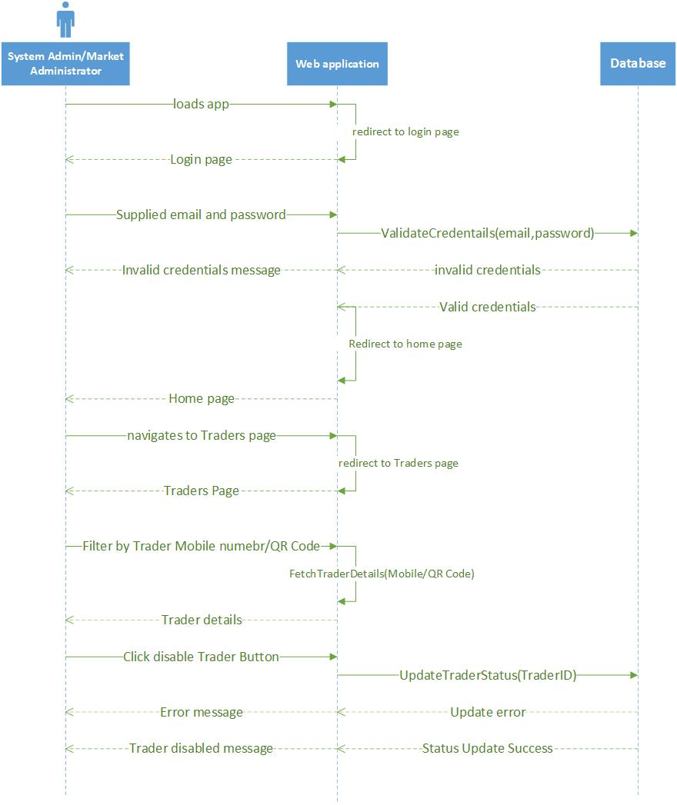

## UNBLOCK TRADER

The use case describes a sequence of events that will occur when a System Admin or Market Administrator wants to unblock a Trader and allow them to use the Market Sales System and the Market facilities.

|  |  |
| --- | --- |
| **Name of use case** | **Unblock Trader** |
| Actor/s | System Admin and Market Administrators |
| Pre-conditions | User must be logged in. |
| Post conditions | User Trader Account successfully unblocked |
| Purpose | To enable System Admins and Market Administrators to unblock Marketeers and Other Traders account. |
| **Main Scenario** | |
| **Actor Input** | **System response** |
| 1. The user navigates to Traders page and Trader Management | 2. The system displays available traders |
| 3. The actor filters by trader mobile number/names | 4. The system filters and displays Trader details |
| 5. The actor clicks Activate trader button | 5.1. The system Activates Trader account by changing account status to 1 |
|  | 5.2. The system displays success message |
| **Alternative Scenario** |  |
|  |  |

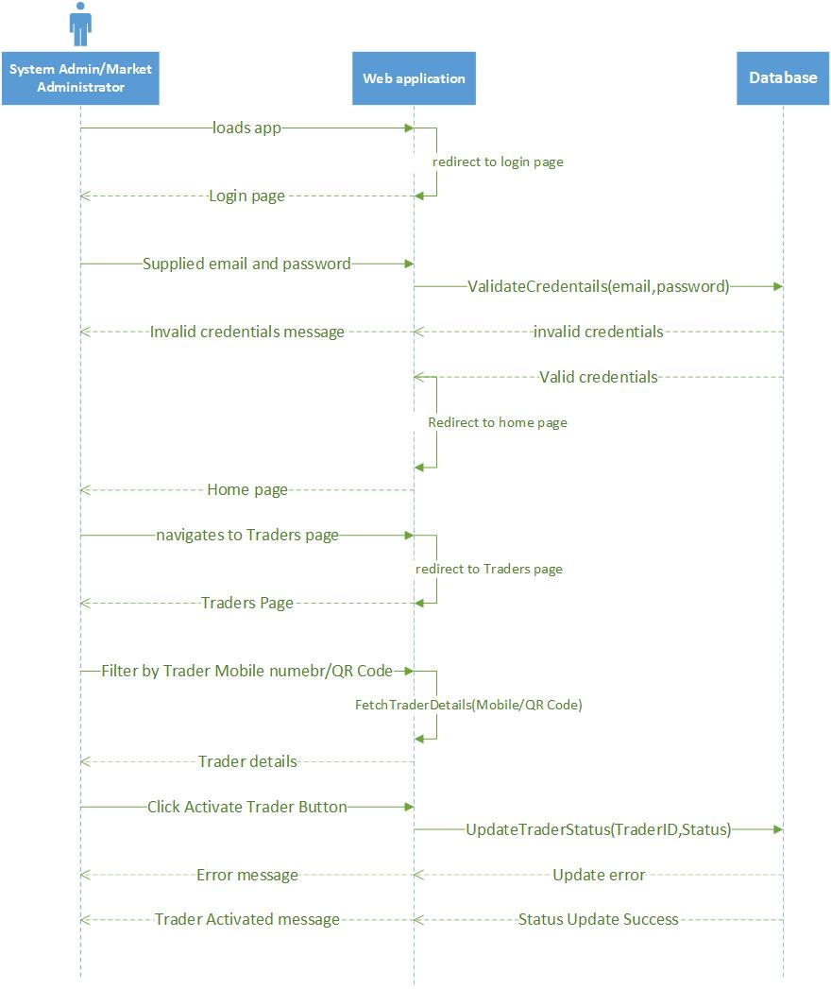

## VIEW SALES

The use case describes a sequence of events that will occur in order for the System Admin or Market Administrators to view Sales for the Marketeers.

|  |  |
| --- | --- |
| **Name of use case** | **View Sales** |
| Actor/s | System Admin and Market Administrators |
| Pre-conditions | User must be logged in. |
| Post conditions | User views Sales/Transactions |
| Purpose | To enable System Admins and Market Administrators to Market transactions |
| **Main Scenario** | |
| **Actor Input** | **System response** |
| 1. The user selects Transactions Page under Transaction Management | 2. The system displays all transactions |
| 3. The actor filters transactions based on Marketeer mobile/QR Code | 4. The system displays Marketeer transactions/Sales |
| 5. The clicks on view Transaction icon | 5.1. The system displays Transaction details |
|  |  |
| **Alternative Scenario** |  |
|  |  |

